The Mystery of the Dark Day

Imagine bundling up in your winter coat, grabbing your snack, and heading out for school under a dark sky filled with stars! The snow on the playground sparkles in the moonlight. Maybe you look up in the sky and see colours so beautiful that you stand in quiet amazement and watch as the colours dance before you.

At lunch you head out and still…no sunshine, only darkness. You feel the sharpness of the cold against your cheeks and hang out with your friends in the dark.

After school, the day goes from dark to even darker! You walk home in silence, hearing the crunch and squeak of snow under your boots.

Could this be true or is it a kind of strange dream? Is there a place in this world where you wake up and spend your whole day in the dark?

Believe it or not, many places in the world experience days where the sun never rises! Kids just like you wake up in the dark, walk to school in the dark, hang out with their friends in the dark, and then walk home to complete their homework in the dark. These periods of 24 hours of darkness are known as the Polar Night!

Now, it would be exaggerating to say that it was pitch black all day long. It isn’t. The sun sometimes comes close to peaking over the horizon around lunch time. It looks a little like the early morning hours just before the sun rise. Not completely dark, but not bright either. Then, the sun sinks far below the horizon and the day becomes as dark as night once more.

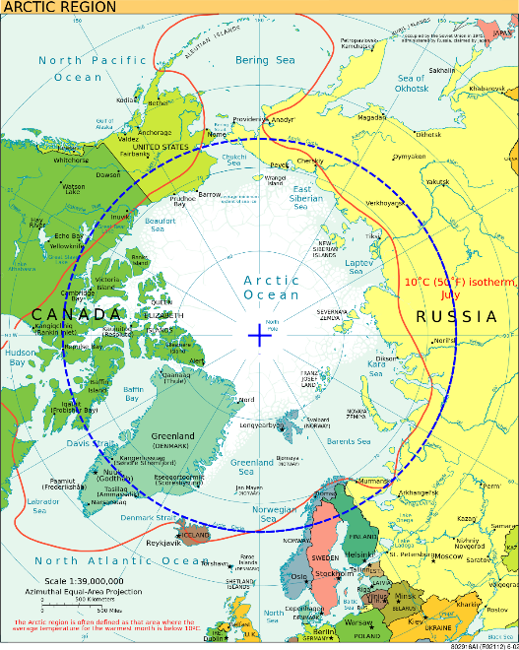Where does this happen? Have you heard of the Arctic Circle? It sits like a cap on the “top” of the globe. If you walked the circumference of this circle, you would travel over 16,000 km through 7 different countries: Canada, Russia, Greenland (Denmark), Norway, Sweden, Finland, and the United States (Alaska).

Why is the Arctic Circle such a dark place? It just so happens that the north part of the Earth is tilted away from the sun in the winter. The North Pole, which is a perfect 90 degrees North in latitude, is as far away from the sun as you can get in the winter. If you’d like to see a more detailed explanation, go to <https://www.youtube.com/watch?v=GmuKAcwa8pk>

The middle of the circle is the North Pole. If you lived at the North Pole, you would experience 163 days of total darkness over the winter. The parts of the countries that are inside the Arctic Circle also experience many days of darkness. People who live there say goodbye to the sun in November or December and don’t see it again until January or February. Can you imagine?

Let’s take a look at some of the communities that exist inside the Arctic Circle.

The largest city inside the Arctic Circle is the Russian port city of Murmansk with a population of around 300,000 people. It lies just inside the circle and experiences dark, sunless days from December 2nd to January 11th. Why would so many people want to live there? It was a very important city during the wars of the twentieth century, especially the Cold War. Russian nuclear submarines prowled the waters of the north like deadly predators. Where was their home base? Murmansk, of course. Even thought the wars have ended, the city is still very important to the Russian Navy. And those deadly submarines? They still exist and more are being built. Why? Good question. Do you dare to find out?

Next, let’s look at a Norwegian city inside the Arctic Circle: Tromso! It has a much smaller population than Murmansk (around 77,000 people), but is a much older. People have been living in Tromso since the end of the last Ice Age over 10,000 years ago! Why? It is beautiful and it is a major centre for Arctic hunting and whaling. The sun sets for the last time of the year on November 27 and doesn’t rise again until January 15th!

Finally, let’s check out the Canadian city of Inuvik. Compared to Tromso and Murmansk it is tiny: only 3,243 people. Inuvik is proud of its cultural and natural heritage. It is a centre of art, amazing wilderness parks, Arctic wildlife, and the famous Sunrise Festival! What’s the Sunrise Festival? Can you guess? That’s right: the whole community celebrates the return of the sun after 30 days of polar night with dancing and feasting, giant bonfires, fireworks, and the main event: approximately 34 minutes of sun! On January 6th, it is expected to rise at 1:44 pm and set again at 2:18 pm.

Did you notice that the polar night was not the same length for these three cities? If you didn’t, go back and look. Which city has the longest polar night? Why do you think this is? Hmmm! There are many mysteries to unravel about the polar night. If you have more questions and are interested in knowing more, we have a research station for you to visit with websites and videos: <https://numeracylab.edublogs.org/2020/11/20/mystery-of-the-dark-research-station/>